Day 3 – Practical Session
Course Code: DSA0612
Course: Data Handling and Visualization
NAME:Dhasvanthini.S(192224096)
1: Weather Data
Date | Temperature (°C) | Humidity (%) | Wind Speed (km/h)
2023-01-01 | 10 | 75 | 15
2023-01-02 | 12 | 70 | 12
2023-01-03 | 8 | 80 | 18
2023-01-04 | 15 | 65 | 20
2023-01-05 | 14 | 72 | 16
- How does temperature vary with humidity and wind speed over the recorded dates?
- Can we visualize the relationship between wind speed and humidity, considering temperature as the third dimension?
- Is there any discernible pattern between temperature, humidity, and wind speed throughout the dataset?
- Create a 3D surface plot to show how temperature changes with varying levels of humidity and wind speed.
- Compare the 3D plots of temperature against both humidity and wind speed separately. Are there any notable differences in trends?
CODE:
library(ggplot2)
library(plotly)
weather_data <- data.frame(
Date = as.Date(c("2023-01-01", "2023-01-02", "2023-01-03", "2023-01-04", "2023-01-05")),
Temperature = c(10, 12, 8, 15, 14),
Humidity = c(75, 70, 80, 65, 72),
WindSpeed = c(15, 12, 18, 20, 16)
)
ggplot(weather_data, aes(x = Humidity, y = WindSpeed, color = Temperature)) +
geom_point(size = 3) +
labs(title = "Temperature Variation with Humidity and Wind Speed",
x = "Humidity (%)", y = "Wind Speed (km/h)", color = "Temperature (°C)") +
theme_minimal()

plot_ly(weather_data, x = ~Humidity, y = ~WindSpeed, z = ~Temperature,
type = "scatter3d", mode = "markers", marker = list(size = 5, color = ~Temperature)) %>%
layout(title = "3D Scatterplot: Wind Speed, Humidity, and Temperature",
scene = list(xaxis = list(title = "Humidity (%)"),
yaxis = list(title = "Wind Speed (km/h)"),
zaxis = list(title = "Temperature (°C)")))
cor(weather_data$Temperature, weather_data$Humidity)
cor(weather_data$Temperature, weather_data$WindSpeed)
library(akima)
interp_data <- with(weather_data, interp(x = Humidity, y = WindSpeed, z = Temperature))

plot_ly(x = interp_data$x, y = interp_data$y, z = interp_data$z,
type = "surface") %>%
layout(title = "3D Surface Plot of Temperature",
scene = list(xaxis = list(title = "Humidity (%)"),
yaxis = list(title = "Wind Speed (km/h)"),
zaxis = list(title = "Temperature (°C)")))
plot_ly(weather_data, x = ~Humidity, y = ~Temperature, z = ~Temperature,
type = "scatter3d", mode = "lines+markers", color = ~Temperature) %>%
layout(title = "Temperature vs Humidity",
scene = list(xaxis = list(title = "Humidity (%)"),
yaxis = list(title = "Temperature (°C)"),
zaxis = list(title = "Temperature (°C)")))
plot_ly(weather_data, x = ~WindSpeed, y = ~Temperature, z = ~Temperature,
type = "scatter3d", mode = "lines+markers", color = ~Temperature) %>%
layout(title = "Temperature vs Wind Speed",
scene = list(xaxis = list(title = "Wind Speed (km/h)"),
yaxis = list(title = "Temperature (°C)"),
zaxis = list(title = "Temperature (°C)")))

OUTPUT:
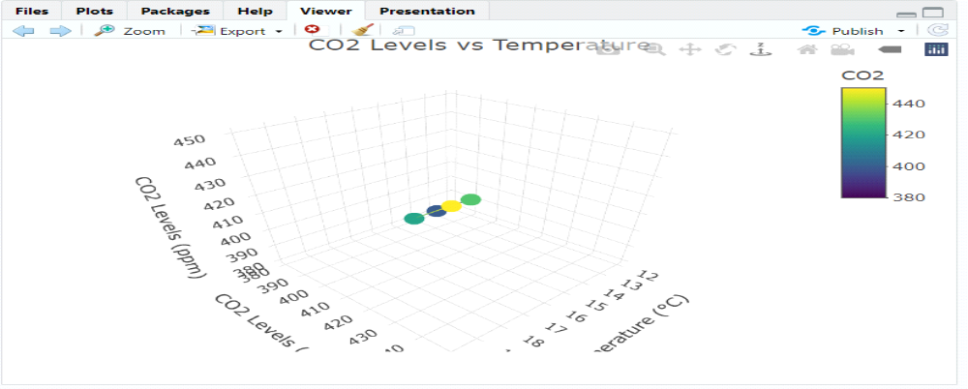
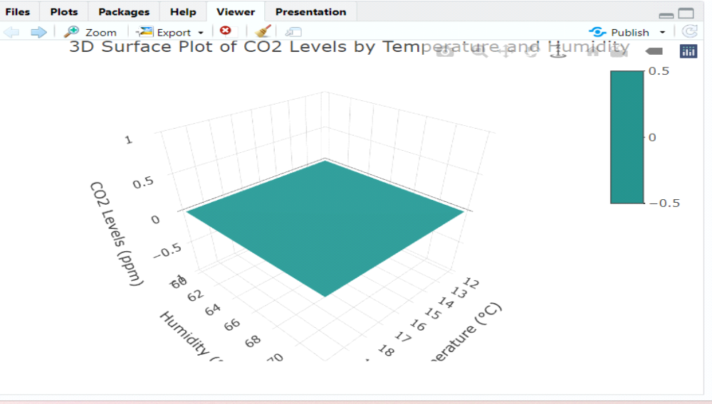

2: Financial Market Data
Date | Stock Price ($) | Volume Traded (millions) | Market Cap ($)
2023-01-01 | 100 | 2.5 | 500
2023-01-02 | 102 | 3.0 | 510
2023-01-03 | 98 | 2.2 | 490
2023-01-04 | 105 | 2.8 | 525
2023-01-05 | 108 | 3.5 | 540
- How does stock price relate to both volume traded and market capitalization?
- Create a 3D scatter plot to visualize the relationship between volume traded, market cap, and stock price.
- Can we see any clustering or outliers in the 3D plot of stock price, volume traded, and market cap?
- Generate a 3D surface plot to illustrate how market capitalization changes with variations in stock price and volume traded.
- Compare the 3D plots of stock price against both volume traded and market cap separately. Are there any noticeable patterns?

library(ggplot2)
library(plotly)
library(akima)
financial_data <- data.frame(
Date = as.Date(c("2023-01-01", "2023-01-02", "2023-01-03", "2023-01-04", "2023-01-05")),
StockPrice = c(100, 102, 98, 105, 108),
VolumeTraded = c(2.5, 3.0, 2.2, 2.8, 3.5),
MarketCap = c(500, 510, 490, 525, 540)
)
ggplot(financial_data, aes(x = VolumeTraded, y = MarketCap, color = StockPrice)) +
geom_point(size = 3) +
labs(title = "Stock Price Relation with Volume Traded and Market Cap",
x = "Volume Traded (millions)", y = "Market Cap ($)", color = "Stock Price ($)") +
theme_minimal()
plot_ly(financial_data, x = ~VolumeTraded, y = ~MarketCap, z = ~StockPrice,
type = "scatter3d", mode = "markers",
marker = list(size = 5, color = ~StockPrice)) %>%
layout(title = "3D Scatterplot: Volume Traded, Market Cap, and Stock Price",
scene = list(xaxis = list(title = "Volume Traded (millions)"),
yaxis = list(title = "Market Cap ($)"),
zaxis = list(title = "Stock Price ($)")))
interp_data <- with(financial_data, interp(x = StockPrice, y = VolumeTraded, z = MarketCap))
plot_ly(x = interp_data$x, y = interp_data$y, z = interp_data$z, type = "surface") %>%
layout(title = "3D Surface Plot of Market Cap",
scene = list(xaxis = list(title = "Stock Price ($)"),
yaxis = list(title = "Volume Traded (millions)"),
zaxis = list(title = "Market Cap ($)")))
plot_ly(financial_data, x = ~VolumeTraded, y = ~StockPrice, z = ~StockPrice,
type = "scatter3d", mode = "lines+markers", color = ~StockPrice) %>%
layout(title = "Stock Price vs Volume Traded",
scene = list(xaxis = list(title = "Volume Traded (millions)"),
yaxis = list(title = "Stock Price ($)"),
zaxis = list(title = "Stock Price ($)")))
plot_ly(financial_data, x = ~MarketCap, y = ~StockPrice, z = ~StockPrice,
type = "scatter3d", mode = "lines+markers", color = ~StockPrice) %>%
layout(title = "Stock Price vs Market Cap",
scene = list(xaxis = list(title = "Market Cap ($)"),
yaxis = list(title = "Stock Price ($)"),
zaxis = list(title = "Stock Price ($)")))
OUTPUT:

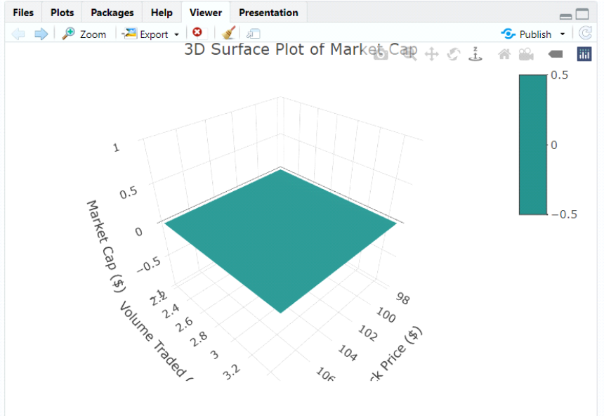
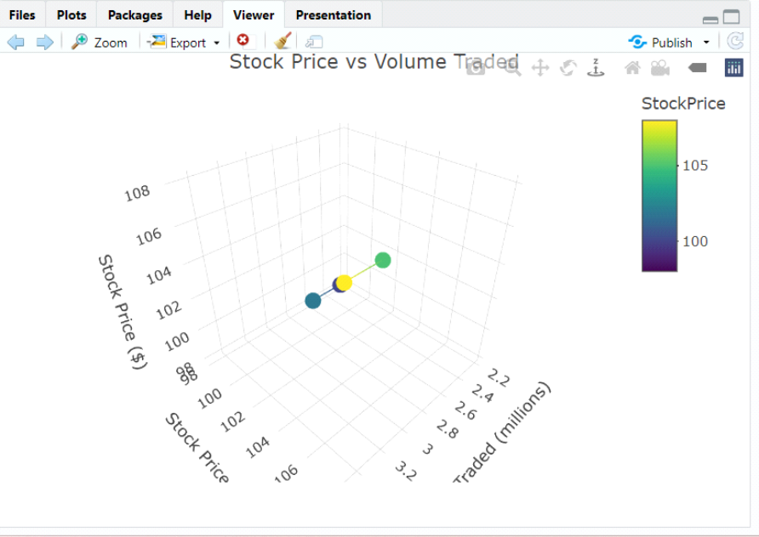

3: Consumer Survey Data
Product | Price ($) | Rating (out of 5) | Age Group
A | 50 | 4.2 | 25-35
B | 70 | 3.8 | 35-45
C | 60 | 4.0 | 18-25
D | 45 | 4.5 | 45-55
E | 55 | 3.9 | 25-35

- How do product ratings vary with both price and age group?
- Create a 3D scatter plot to visualize the relationship between price, rating, and age group.
- Is there a correlation between age group, product price, and consumer ratings based on the 3D plot?
- Generate a 3D surface plot to show how product ratings change with variations in both price and age group.
- Compare the 3D plots of product ratings against both price and age group separately. Are there any significant insights?
CODE:
library(ggplot2)
library(plotly)
library(akima)
survey_data <- data.frame(
Product = c("A", "B", "C", "D", "E"),
Price = c(50, 70, 60, 45, 55),
Rating = c(4.2, 3.8, 4.0, 4.5, 3.9),
AgeGroup = factor(c("25-35", "35-45", "18-25", "45-55", "25-35"))
)
ggplot(survey_data, aes(x = Price, y = Rating, color = AgeGroup)) +
geom_point(size = 3) +
labs(title = "Product Ratings vs Price by Age Group",
x = "Price ($)", y = "Rating (out of 5)", color = "Age Group") +
theme_minimal()
plot_ly(survey_data, x = ~Price, y = ~Rating, z = ~as.numeric(AgeGroup),
type = "scatter3d", mode = "markers",
marker = list(size = 5, color = ~Rating, colorscale = "Viridis")) %>%
layout(title = "3D Scatterplot: Price, Rating, and Age Group",
scene = list(xaxis = list(title = "Price ($)"),
yaxis = list(title = "Rating (out of 5)"),
zaxis = list(title = "Age Group (Numeric)")))
survey_data$AgeGroupNumeric <- as.numeric(survey_data$AgeGroup)
correlation_price_rating <- cor(survey_data$Price, survey_data$Rating)
correlation_price_age <- cor(survey_data$Price, survey_data$AgeGroupNumeric)
correlation_rating_age <- cor(survey_data$Rating, survey_data$AgeGroupNumeric)

cat("Correlation between Price and Rating:", correlation_price_rating, "\n")
cat("Correlation between Price and Age Group:", correlation_price_age, "\n")
cat("Correlation between Rating and Age Group:", correlation_rating_age, "\n")
interp_data <- with(survey_data, interp(x = Price, y = as.numeric(AgeGroup), z = Rating))
plot_ly(x = interp_data$x, y = interp_data$y, z = interp_data$z, type = "surface") %>%
layout(title = "3D Surface Plot of Ratings by Price and Age Group",
scene = list(xaxis = list(title = "Price ($)"),
yaxis = list(title = "Age Group (Numeric)"),
zaxis = list(title = "Rating (out of 5)")))
plot_ly(survey_data, x = ~Price, y = ~Rating, z = ~Rating,
type = "scatter3d", mode = "lines+markers", color = ~Rating) %>%
layout(title = "Ratings vs Price",
scene = list(xaxis = list(title = "Price ($)"),
yaxis = list(title = "Rating (out of 5)"),
zaxis = list(title = "Rating (out of 5)")))
plot_ly(survey_data, x = ~as.numeric(AgeGroup), y = ~Rating, z = ~Rating,
type = "scatter3d", mode = "lines+markers", color = ~Rating) %>%
layout(title = "Ratings vs Age Group",
scene = list(xaxis = list(title = "Age Group (Numeric)"),
yaxis = list(title = "Rating (out of 5)"),
zaxis = list(title = "Rating (out of 5)")))

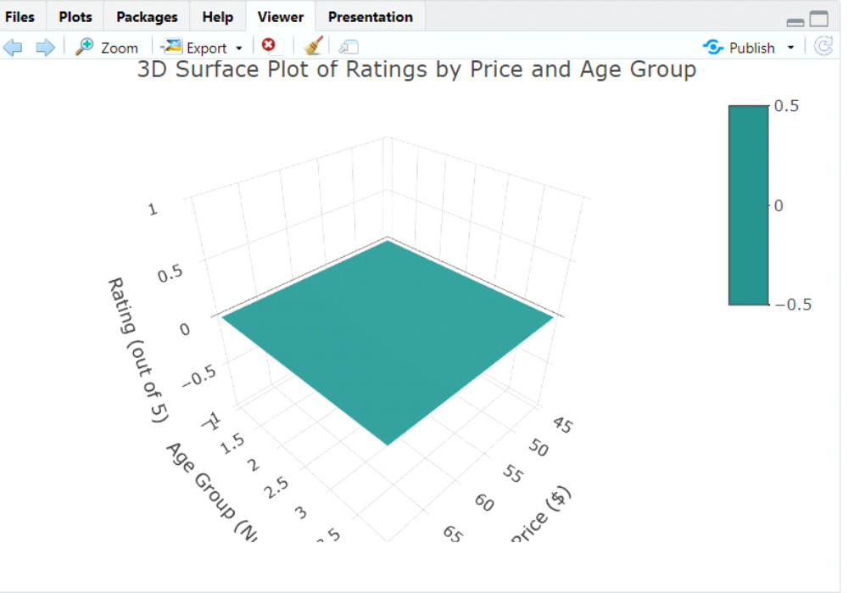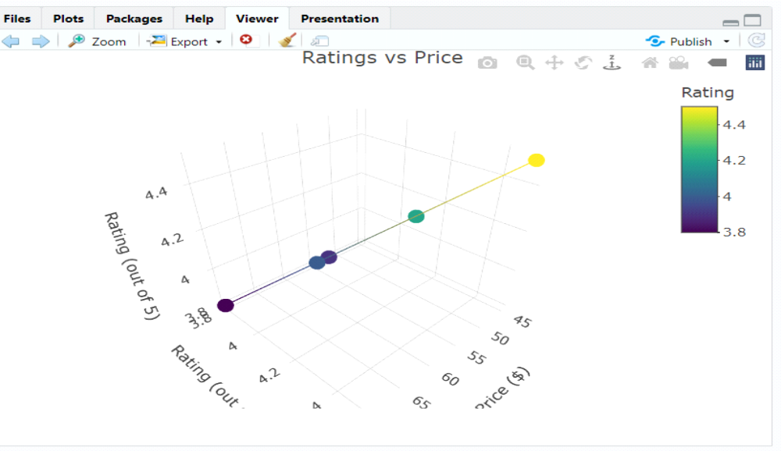

4: Environmental Data
Location | Temperature (°C) | Humidity (%) | CO2 Levels (ppm)
A | 15 | 65 | 400
B | 20 | 70 | 450
C | 18 | 68 | 420
D | 12 | 60 | 380
E | 17 | 72 | 430
- How do CO2 levels vary with both temperature and humidity across different locations?
- Create a 3D scatter plot to visualize the relationship between temperature, humidity, and CO2 levels.
- Is there a spatial pattern in the 3D plot of temperature, humidity, and CO2 levels among the locations?
- Generate a 3D surface plot to illustrate how CO2 levels change with variations in both temperature and humidity.
- Compare the 3D plots of CO2 levels against both temperature and humidity separately. Are there any noticeable trends?
CODE:
library(ggplot2)
library(plotly)
library(akima)
env_data <- data.frame(
Location = c("A", "B", "C", "D", "E"),
Temperature = c(15, 20, 18, 12, 17),
Humidity = c(65, 70, 68, 60, 72),
CO2 = c(400, 450, 420, 380, 430)
)
ggplot(env_data, aes(x = Temperature, y = Humidity, color = CO2)) +
geom_point(size = 4) +
labs(title = "CO2 Levels vs Temperature and Humidity",
x = "Temperature (°C)", y = "Humidity (%)", color = "CO2 Levels (ppm)") +
theme_minimal()
plot_ly(env_data, x = ~Temperature, y = ~Humidity, z = ~CO2,
type = "scatter3d", mode = "markers",
marker = list(size = 5, color = ~CO2, colorscale = "Viridis")) %>%
layout(title = "3D Scatterplot: Temperature, Humidity, and CO2 Levels",
scene = list(xaxis = list(title = "Temperature (°C)"),
yaxis = list(title = "Humidity (%)"),
zaxis = list(title = "CO2 Levels (ppm)")))
correlation_temp_co2 <- cor(env_data$Temperature, env_data$CO2)
correlation_humidity_co2 <- cor(env_data$Humidity, env_data$CO2)

cat("Correlation between Temperature and CO2 Levels:", correlation_temp_co2, "\n")
cat("Correlation between Humidity and CO2 Levels:", correlation_humidity_co2, "\n")
interp_data <- with(env_data, interp(x = Temperature, y = Humidity, z = CO2))
plot_ly(x = interp_data$x, y = interp_data$y, z = interp_data$z, type = "surface") %>%
layout(title = "3D Surface Plot of CO2 Levels by Temperature and Humidity",
scene = list(xaxis = list(title = "Temperature (°C)"),
yaxis = list(title = "Humidity (%)"),
zaxis = list(title = "CO2 Levels (ppm)")))
plot_ly(env_data, x = ~Temperature, y = ~CO2, z = ~CO2,
type = "scatter3d", mode = "lines+markers", color = ~CO2) %>%
layout(title = "CO2 Levels vs Temperature",
scene = list(xaxis = list(title = "Temperature (°C)"),
yaxis = list(title = "CO2 Levels (ppm)"),
zaxis = list(title = "CO2 Levels (ppm)")))
plot_ly(env_data, x = ~Humidity, y = ~CO2, z = ~CO2,
type = "scatter3d", mode = "lines+markers", color = ~CO2) %>%
layout(title = "CO2 Levels vs Humidity",
scene = list(xaxis = list(title = "Humidity (%)"),
yaxis = list(title = "CO2 Levels (ppm)"),
zaxis = list(title = "CO2 Levels (ppm)")))

OUTPUT:
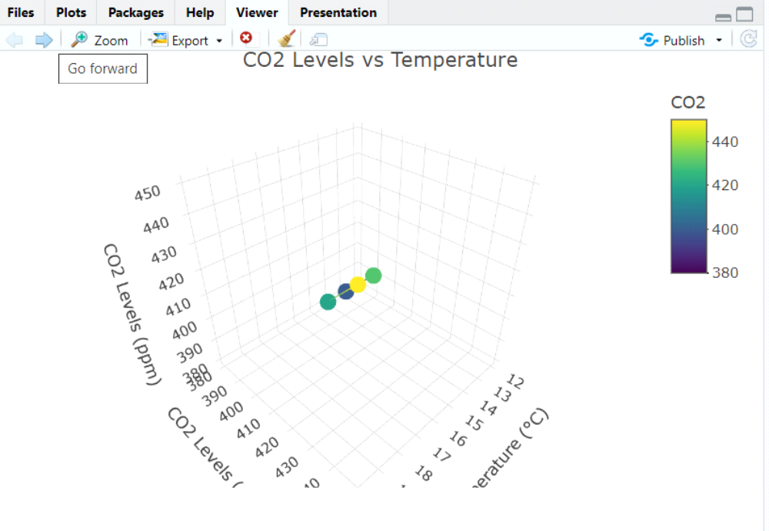

5: Academic Performance Data
Student | Math Score | Science Score | Attendance (%)
A | 85 | 78 | 95
B | 72 | 85 | 92
C | 90 | 80 | 98
D | 78 | 75 | 85
E | 88 | 82 | 93
- How do science scores vary with both math scores and attendance percentage?
- Create a 3D scatter plot to visualize the relationship between math score, science score, and attendance.
- Is there a correlation between attendance, math scores, and science scores based on the 3D plot?
- Generate a 3D surface plot to show how science scores change with variations in both math scores and attendance.
- Compare the 3D plots of science scores against both math scores and attendance separately. Are there any significant patterns or outliers?
CODE:
library(ggplot2)
library(plotly)
library(akima)
academic_data <- data.frame(
Student = c("A", "B", "C", "D", "E"),
Math_Score = c(85, 72, 90, 78, 88),
Science_Score = c(78, 85, 80, 75, 82),
Attendance = c(95, 92, 98, 85, 93)
)
ggplot(academic_data, aes(x = Math_Score, y = Attendance, color = Science_Score)) +
geom_point(size = 4) +
labs(title = "Science Scores vs Math Scores and Attendance",
x = "Math Score", y = "Attendance (%)", color = "Science Score") +
theme_minimal()
plot_ly(academic_data, x = ~Math_Score, y = ~Attendance, z = ~Science_Score,
type = "scatter3d", mode = "markers",
marker = list(size = 5, color = ~Science_Score, colorscale = "Viridis")) %>%
layout(title = "3D Scatterplot: Math Score, Attendance, and Science Score",
scene = list(xaxis = list(title = "Math Score"),
yaxis = list(title = "Attendance (%)"),
zaxis = list(title = "Science Score")))

correlation_math_science <- cor(academic_data$Math_Score, academic_data$Science_Score)
correlation_attendance_science <- cor(academic_data$Attendance, academic_data$Science_Score)

cat("Correlation between Math and Science Scores:", correlation_math_science, "\n")
cat("Correlation between Attendance and Science Scores:", correlation_attendance_science, "\n")
interp_data <- with(academic_data, interp(x = Math_Score, y = Attendance, z = Science_Score))
plot_ly(x = interp_data$x, y = interp_data$y, z = interp_data$z, type = "surface") %>%
layout(title = "3D Surface Plot of Science Scores by Math Score and Attendance",
scene = list(xaxis = list(title = "Math Score"),
yaxis = list(title = "Attendance (%)"),
zaxis = list(title = "Science Score")))
plot_ly(academic_data, x = ~Math_Score, y = ~Science_Score, z = ~Science_Score,
type = "scatter3d", mode = "lines+markers", color = ~Science_Score) %>%
layout(title = "Science Scores vs Math Scores",
scene = list(xaxis = list(title = "Math Score"),
yaxis = list(title = "Science Score"),
zaxis = list(title = "Science Score")))
plot_ly(academic_data, x = ~Attendance, y = ~Science_Score, z = ~Science_Score,
type = "scatter3d", mode = "lines+markers", color = ~Science_Score) %>%
layout(title = "Science Scores vs Attendance",
scene = list(xaxis = list(title = "Attendance (%)"),
yaxis = list(title = "Science Score"),
zaxis = list(title = "Science Score")))
OUTPUT:
